Title- SONAR SIGNAL PREDICTION USING EXPLAINABLE AI FOR IoT ENVIRONMENT

Abstract – In the recent years we have witnessed rapid advancements in IoT and IIoT industries giving a huge momentum to computational technologies like Data Analytics, Artificial Intelligence, Visual Computing, etc. Data Science had its influence in such a powerful way that its application became omnipresent in every category of applicable science. Along with that there urged emergence of myriad of predicaments that many computing sectors face in different forms and hence propelled towards novels methods to solve using appropriate strategies. Therefore application of Artificial Intelligence which predicts outcomes based of data acquisition became more frequent. Considering all this Sonar was one of the IoT areas where most problems were arising for future research. In addition to implementation of AI followed a Blackbox system and from then various attempts are being carried to convert them into glass box with the help of Explainable AI. Most of the research and the PhDs are fully fledged towards Explainable AI and to extend its use in all relevant domains.

Keywords – AI in IoT, Sonar Radiation, Explainable AI, Prediction

1. Introduction –

In the past couple of years, one can observe increasing ubiquity of sensors in IoT platforms for betterment in industrial solutions. Nowadays introduction of sonar into sensors for predicting movements, patterns, sea levels, type of material, etc. is rapidly becoming prevalent. Hence, implementation of AI for detection is becoming a great deal in IoT sector. This paper has a predictive analysis approach covering the part of XAI, where transparent machine learning models used for predicting sonar signals consolidate new explanation styles and also the strategies to explain black box systems.

Although, studies have been made on using of AI/ML algorithms such as neural networks, target recognition, deep learning and classifiers for sonar radiation prediction, applying XAI techniques is still in under saturation, as till date it’s still a novel approach even for computer sectors. Moreover classification and neural networks have been immensely practiced for predicting the signals. Hence, the study gives a brief outlook on execution of explainable AI models like LIME, ELI5 , SHAP which are then compared to conventional machine learning models used like- knn, logistic regression, random forest classifier, etc.

Dataset is typically based on sonar signals of mines and rocks. The first section covers detailed information about the chosen sonar dataset and the preprocessing that generally accompanies it. Next section covers comprehensive information on XAI models and their functionality. The successive sections discuss the approaches and experimental methods incorporated into the research, the discussions based on the outcomes of the different algorithms used for comparison. Final section addresses the potential outcome of all the study and how the study differentiates from the results of previous studies.

2. Motivation:

As we can state, IoT implemented in industrial as well as household has its vast flexibility in accepting multi-disciplinary projects to obtain wishful result, and all this is carried out by the integration of data analysis, software comuting, cloud computing, sensors and actuators. Even the intractable system can be resolved by proper channeling of IoT in the respective system. Considering the software part coding generally follows it and that’s the point of area where Machine learning and Artificial Intelligence encompassing diverse algorithms and model are to put to exercise for simplifying the arduous processes and predictions. Judged by this criterion in order to achieve more delineation for the gained interpretation more clarification is vital which is carried out by explainable AI methods. As of today performing XAI is still rare and therefore, I intend to devote my study on such application of Explainable AI process ensemble in IoT domain.

1. Related Work

A detail explanation of related work is given below:

1. R. Paul Gorman and Terrence J. Sejnowski proposed an analysis of hidden units in multilayered network. Proposed work classified their experimentation as Aspect angle dependent and Independent series. A brief comparison was made using nearest neighbor classifier along with their study outcome and hidden units were discovered. Their research concluded with a result that performance classifier is good than nearest neighbor classifier and that it can provide more alternative techniques to existing ML models.
2. Pınar O¨ zkan, Bakbak and Musa Peker proposed classification of sonar signals in reduced sparse forms. They implemented CVANN and CVSC algorithm on the same dataset we chose and compared. The proposed work is a novel method of using complex-valued wavelet neural network and transferring signals to DFT domain, hence proving that CVSC and CVWANN using together is a successful method for classifying sonar echo signals.
3. Anton Kummert proposed detailed work on application of Fuzzy algorithms in Sonar. Various applications of Sonar like propeller shaft blades and target tracking system were used of applying fuzzy technology. He proposed various analytical and mechanical works like DEMON analysis, fuzzification and defuzzification, etc. Overall research was more inclined towards application of ruled based fuzzy algorithms on different sonar applications and this study was buoyantly implemented in ATLAS sonar equipment.
4. V.V. Prokopovich, A.V. Shafranyuk proposed a model for detecting signal of passive sonar system. Hydroacoustic systems (HAS) was the core area of focus of this research w.r.t data pre-processing. The study proves that it is easy to stimulate signal marks to debug tracking analysis algorithms and to solve primary data display but they weren’t able to cover other possible issues of close angular arrangement, distribution density function of a stream of false marks, estimation of the consistency due to their wide scope.
5. Venkataraman Padmaja, V. Rajendran and P. Vijayalakshmi proposed research applying data mining and machine learning techniques on metal mine detection on underwater sonar images. Implementation of ML techniques like SVM, KNN classifier, SOM and Gradient booster for image processing and ML prediction and also give an in depth knowledge of the same AI techniques. Finally they have proved that Gradient Booster classifier results in better accuracy in discrimination and prediction of metal mine from rock
6. Gap Analysis:

Studies have unambiguously shown the usage of ML and AI models in myriad of segments using proficient tools like Natural language processing, Deep learning, Neural Networking, etc. But as they are considered black boxes, their magnitude of interpretability is doubted. In order to obtain high interpretability one needs to understand the mathematical significance of underlying respective algorithms as well as the mechanism of the models. ‘Explainability’ plays a major role, for AI has to deal with the accuracy of the interpretability whereas Explainable AI has to do with justifying the output and hidden nets. Further comes the second crucial aspect of Explainable AI that is ‘Transparency’ which measures the degree of transparency of conventional AI which expresses different levels of features and hence the capacity of understanding it may it be algorithmic transparency, decomposability , visual and local explanations. If to take a deep inside look there are other esoteric terminologies in XAI like post-hoc explainability, model agnostic techniques (LIME, G-REX), feature and visual explainable techniques (SHAP, SA, ASTRID). To simply sum up all, Explainable AI is the most sophisticated and advanced method to find succinct explanations of AI systems.

1. Proposed Work
   1. Methodology

Perspective followed in this paper first is the collection of the appropriate data congruous with IoT domains. Accordingly, as Sonar radiation is prevailing in applications of IoT and IIoT discipline, therefore it was subsequently preferred and the dataset was finalized. Additionally to achieve some dexterity for analytical and experimental purposes the data was prepared, accompanied by training and feature scaling. Further approach was the building of relevant machine learning models covering all the essential part of ML testing and training of data. Finally perceivingthe mandatory outcome which can be carried out in the form of prediction, recommendation or forecasting.

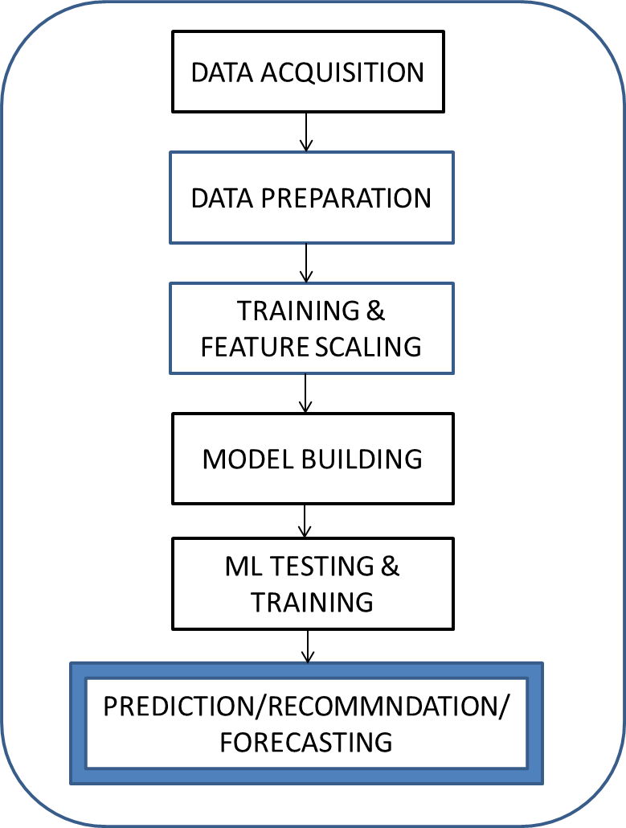

4.2 Dataset

The dataset is referred from the UCI repository. Dataset is a mixture of sonar signals gathered from bouncing signals from surfaces of rocks and mines. Total of 60 columns and 208 indexes are formed from the rebound signals of rocks and mines. Mine’s signal contains 111 patterns obtained by bouncing sonar signals off a metal cylinder at various angles and under various conditions. On the other hand rock’s contains 97 patterns obtained from rocks under similar conditions. The imparted sonar signals are frequency-modulated chirp, peaking in frequency. The data contains signals of a diverse of different aspect angles, spanning 90 degrees for the cylinder and 180 degrees for the rock. The pattern is found to be of 60 numbers ranging from 0.0 to 1.0. Each number denotes the energy within a particular frequency, integrated over a certain period of time.

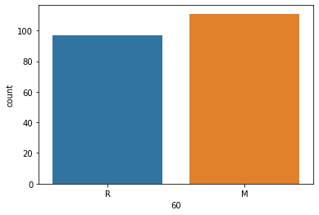

Figure 1

Analysis was done using histogram count plot and to discover an appropriate heatmap of correlation was generated covering about 58 points in X and Y axis.

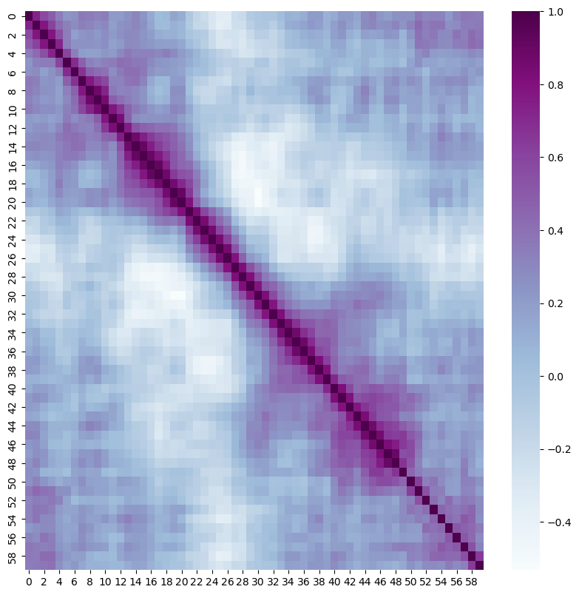

Figure 2

4.3 IMPLEMENTATION OF ML MODELS

Initially data preprocessing and analysis was done on the chosen dataset. Label encoding was performed on the last column as the last column indicated whether the signal reflected from rock or mine and consisted of ‘M’ and ‘R’. Machine learning models K Nearest Neighbor Classifier and Random Forest Classifier were then implemented for further research on prediction, comparison as well as to analyze various merits and drawbacks that occur in the process. Both the models are classification based models which were chosen in order to check better efficiency by comparison.

KNN algorithm was preferred because of its easy application and as it is widely used in data classification model. The simplicity and the versatility of KNN to form different clusters of same features are the main significance of this model. Accordingly, after the data prepossessing, dataset was split into 90% train and 10% test set. Further it was scaled for the features of pipeline and then created model for pipeline. Next step was finding the best K parameter with the help of grid search and the respective results were generated of which the mean test score column was plotted denoting the desired result.

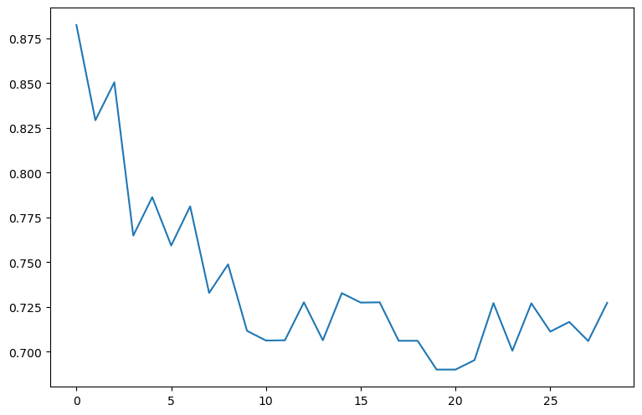

Figure 3. Plot of Mean test Score (KNN grid_search _parameter)

Correspondingly, Random Forest Classifier as mentioned before was the second classification algorithm chosen to classify this dataset other than K Nearest Neighbor. What is really remarkable about random forest classifier is that it can sustain big dimensional spaces along with large amount of training samples. Widely known for its high level accuracy predictions than most of the classification algorithms, the key point here to note is that it yields more rational prediction without hyper parameter tuning.

Mention should also be made of its working principle and outcomes based on many decision trees and bagging (Meta algorithm).

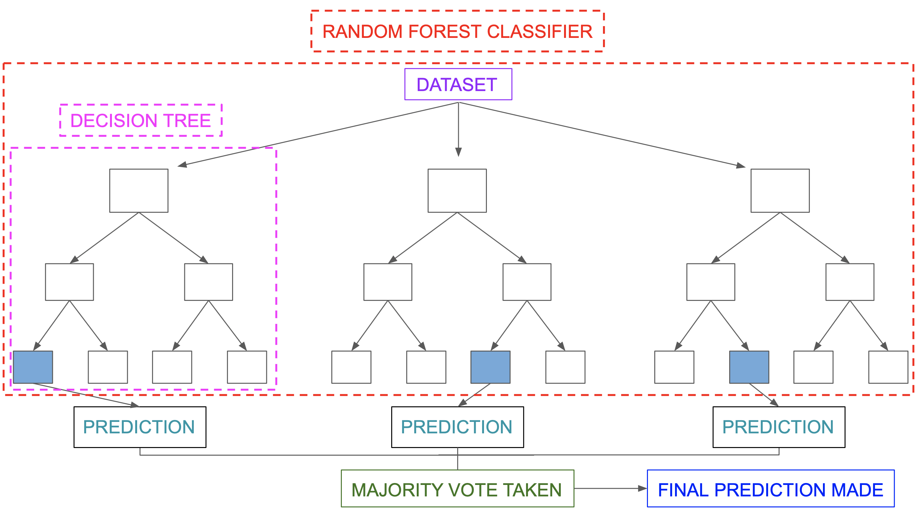

Figure 4. Basic Flowchart of Random Forest Classifier

So its use in the code was no doubt propitious, this also takes to the heart of the matter that the number of meta estimators (n_estimators) given were 50 which play a major role on building the decision trees and fitting them on subsets of main dataset before even making prediction.

4.4 Incorporation of Explainable Model:

In order to solve the black box systems adhered in Artificial Intelligence use of explainable AI was introduced to give added and also to corroborate an unprecedented predictions and results in coding. So models like LIME which is an acronym for Local interpretable model-agnostic explanations, SHAP acronym for SHapley Additive exPlanations, ELI5, etc. are some of the top notch Explainable AI models. It also should be emphasised that the XAI models not only endorse for interpretable and transparent ML algorithms but also provides unique strategies for explaining black box systems. Use of Random forest is explicitly applied in this research because there is no denying that it is a black box system due to the large number of decision trees.

ELI5

ELI5 is used for debugging various ML models and algorithms and thus give elucidation for their prediction. The first and foremost thing here to initiate any explainable models is to install them from python packages. Judging by the ELI5 library and its working it’s mainly used for unraveling XGBoost, regressors and classifiers, Keras, CatBoost, etc. Therefore, the last section of the study is the implementation of ELI5 model which gives an absolute explanation to our outcome predictions.

1. Result and Discussion

Now that all the intended machine learning models i.e. KNearsest Neighbour and Random Forest are applied on dataset and are used to predict whether the signal is from rock or mine, appropriate results are obtained.

The results are represented in tabular form :

|  |  |  |  |  |
| --- | --- | --- | --- | --- |
|  | precision | recall | f1-score | support |
| 0 | 0.90 | 0.82 | 0.86 | 11 |
| 1 | 0.82 | 0.90 | 0.86 | 10 |
| accuracy |  |  | 0.86 | 21 |
| macro avg | 0.86 | 0.86 | 0.86 | 21 |
| weighted avg | 0.86 | 0.86 | 0.86 | 21 |

Table 1. Tabular representation of K Nearest Neighbor prediction

|  |  |  |  |  |
| --- | --- | --- | --- | --- |
|  | precision | recall | f1-score | support |
| 0 | 1.00 | 0.91 | 0.95 | 11 |
| 1 | 0.91 | 1.00 | 0.95 | 10 |
| accuracy |  |  | 0.95 | 21 |
| macro avg | 0.95 | 0.95 | 0.95 | 21 |
| weighted avg | 0.95 | 0.95 | 0.95 | 21 |

Table 2. Tabular representation of Random Forest Classifier prediction

The first thing we notice is that the precision of Random forest classifier is greater than KNN, this can be considered even if we compare the whole precision column for both models. Mention should also be made of the accuracy which gives the best explanation between the competences for these two models, that accuracy of Random Forest is greater by 0.09 units than KNN. All things considered then. Random forest proves a better prediction model for this dataset and the further explanation is supported by ELI5 method. Hence, the two tables give a clear picture also on the efficiency of application of these two models.

Explainable AI  
For interpreting our results we have used the Shapash library. There are 2 of explanations that we have provided for the model we have developed. The global importance explains overall which were the columns that our model considered the most in making contributions or which were the columns who contributed most to the predictions.   
The following graph shows the explanations provided by our explainable ai module.  
From the graph it can be observed that the factor that contributed most to the predictions was the column 10 followed by columns 48,11 and so on.   
The following graph shows the factors that contributed most to a specific row/instance.   
We observed that the final response obtained was 1. The factors those contributed most to this outcome were 10,11,48,47 and 9. From this, we can understand that to get an outcome of 1 having values as the columns 10,11,9 for this instance, we can have values similar to values in column 9 and not like colmns 48,47 or 51. This is extremely important as it can help to distinguish between 2 similar instances. Strong rules and filters can also be derived to develop high level business decisions.

1. Conclusions and Future Work

The study gives a detailed demonstration of application of K Nearest Neighbor, Random Forest Classifier and ELI5 to predict and explain SONAR radiation signals. Final analysis proves that Random forest is better model than KNN and ELI5 was successfully implemented on Sonar dataset. Considering the results it seems clear that it has thoroughly delineated the predictions of random forest model and hence, eased its understanding of interpretation. Therefore, now it does not seem hard to question its explainability and transparency and makes difficult to escape the conclusion that it provides ample information on characteristics and attributes of random forest model. Study is totally in favour of researchers who are working in Sonar IoT platforms.

The research provides a very productive approach in implementing XAI for sonar dataset and hence can be a further motivation towards the use of XAI in different IoT domains creating great level of advanced explainability along with pertinent research. More studies already give a brief picture about its extrapolation in medical fields specifically in cancer. This is not to say that they are restricted only to science and technology but it can yield to influence in nonscientific domains such as musicology, statistics, etc. We can evidence it’s gradual motivation in image processing, visual computing and data analytics.To sum up XAI has great potential to explain diverse black box systems .

1. References